Content Server is a Web-based application for storing, sharing, and distributing information. It provides a collaborative work environment that helps your organization manage documents and project information, improve business processes, and share information.
*permission control on object
*share, find, and keep track of information
*revise documents and other information in a version-controlled environment
*manage and simplify business processes by creating and using Workflows
----------------------------------
Project
*Where COORD indicates a Coordinator. For the scenario where PUBLIC permissions can be updated for PPM objects (PERMACTION:PUBLIC:UPDATE:<perms>), the acceptable values for <perms> in this case is ENABLED or DISABLED.

-COORD
-MEMBER
-GUEST

*SPM
SEE See
SEECONTENTS See Contents
MODIFY Modify
EDITATTRS Edit Attributes
RESERVE Reserve or Checkout
DELETEVERS Delete Versions
DELETE Delete the Object
EDITPERMS Edit Permissions
ADDITEMS Add Items

*WPM
To specify permissions for WPM objects (Eg. discussions, channels, task lists, etc), the following table displays the keywords that can be substituted for <perms> in any of the applicable PERMACTION operations:

NONE
READ
WRITE
ADMINISTER
-------------------------------
The Enterprise Workspace

The Enterprise Workspace is the public forum in Content Server. It is used to store information and items that are intended for all users in your organization to see and work with. Although all users typically have the ability to see the items in the Enterprise Workspace, only a select number receive permission to add, delete, or modify items there.

Note

Note:
Permissions control your access to everything in Content Server. For more information about permissions, see Understanding Permissions.

The My Workspace

Every user has a private storage area called My Workspace which is accessed by clicking Personal on the Global Menu Bar, then clicking My Workspace. You have full permissions on your personal Workspace, which displays as <your_userid> Home. For more information about your personal Workspace, see Using My Home.

The Project Workspace

Projects are unique in the sense that they are added to Content Server like an item, but each one functions as a discrete Workspace. Every Project added to Content Server receives its own Workspace, which is accessible only to users who are assigned to participate in it. For more information about the Project Workspace, see Working with Projects.

Note

Note:
Another unique aspect of Projects is that they have their own permissions model. For more information, see Understanding Project Role Permissions.

Containers

Containers are items that organize the information stored in Content Server in a systematic way. The most common Container type, because it can store almost any type of item, is the Folder. Other Containers, such as Discussions and Compound Documents, can store only certain kinds of items. Different Containers have different characteristics and unique functions. For more information about containers and other item types, see Understanding Items.

Note

Note:
Workspaces and Containers are sometimes collectively referred to as locations.
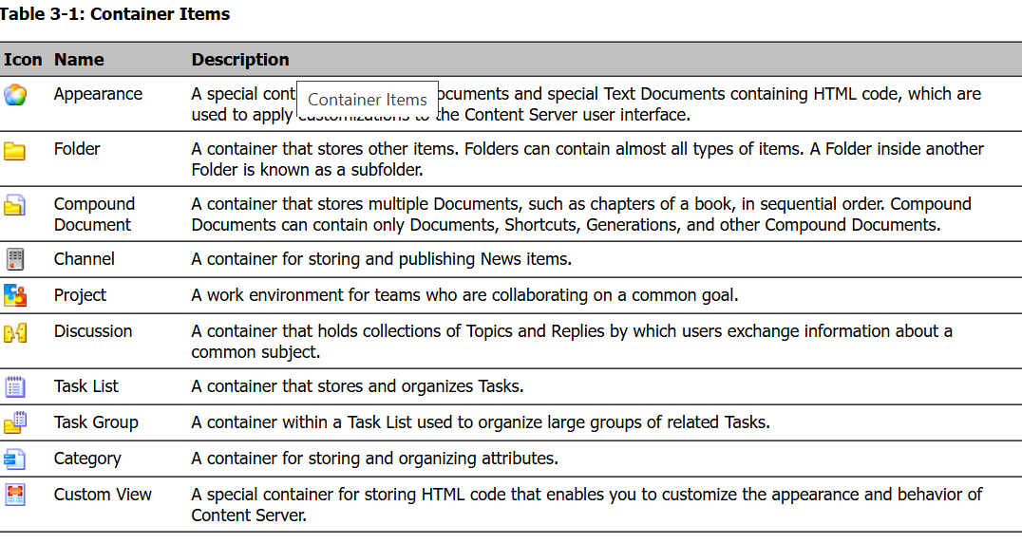

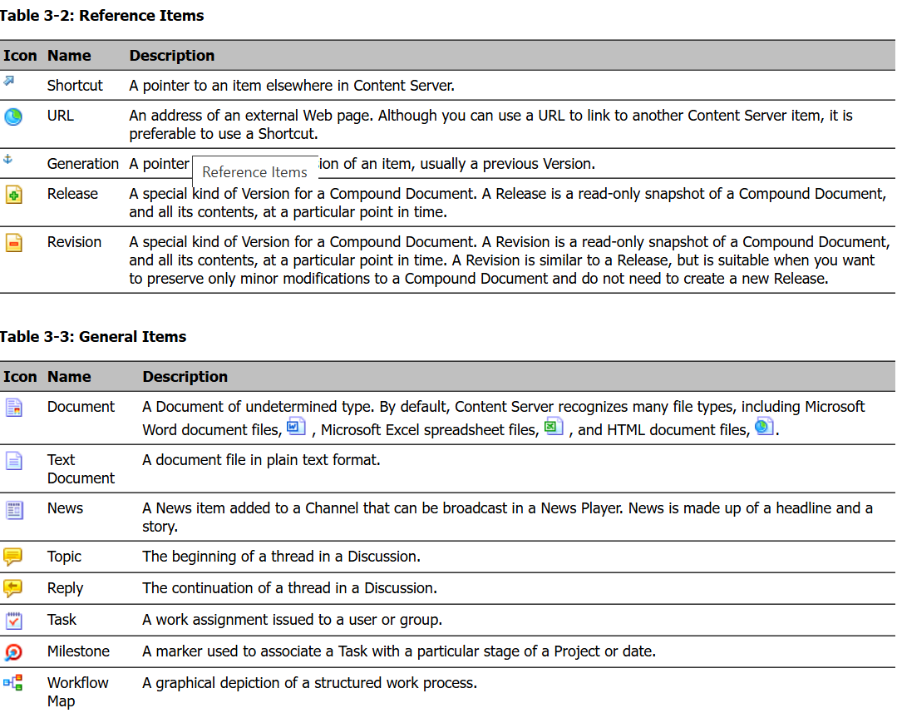
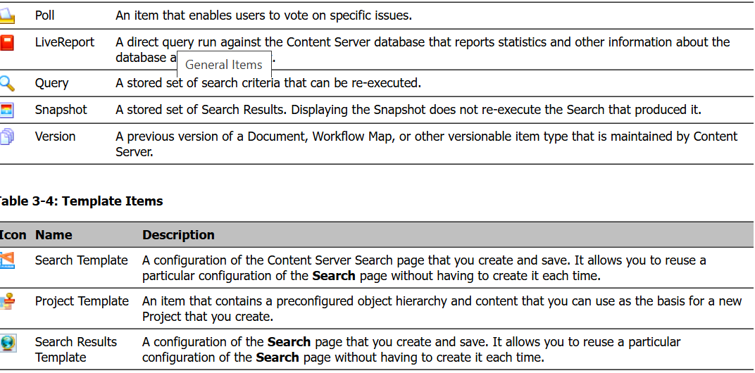

Groups: The principal group of which you are a member is called your Department
Permissions: Types of Permissions
There are three distinct but related types of permissions:
- Work Item permissions, which apply to Collections, Channels, Discussions, and Task Lists.
- Document Management permissions, which apply to most item types.
- Role-Based permissions, which apply to Projects.

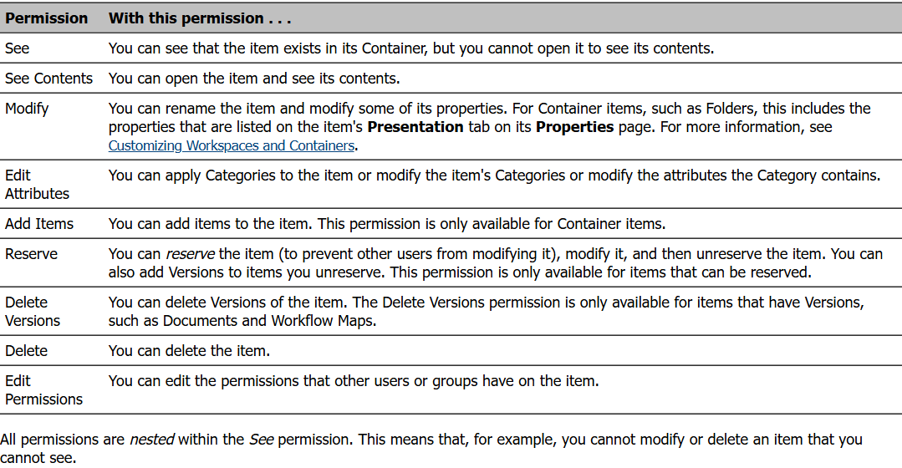

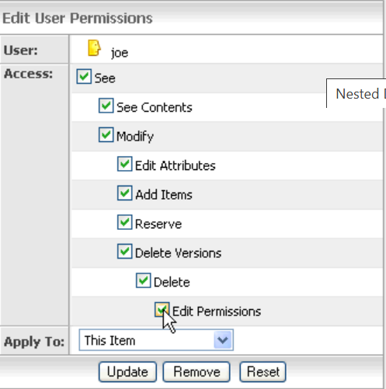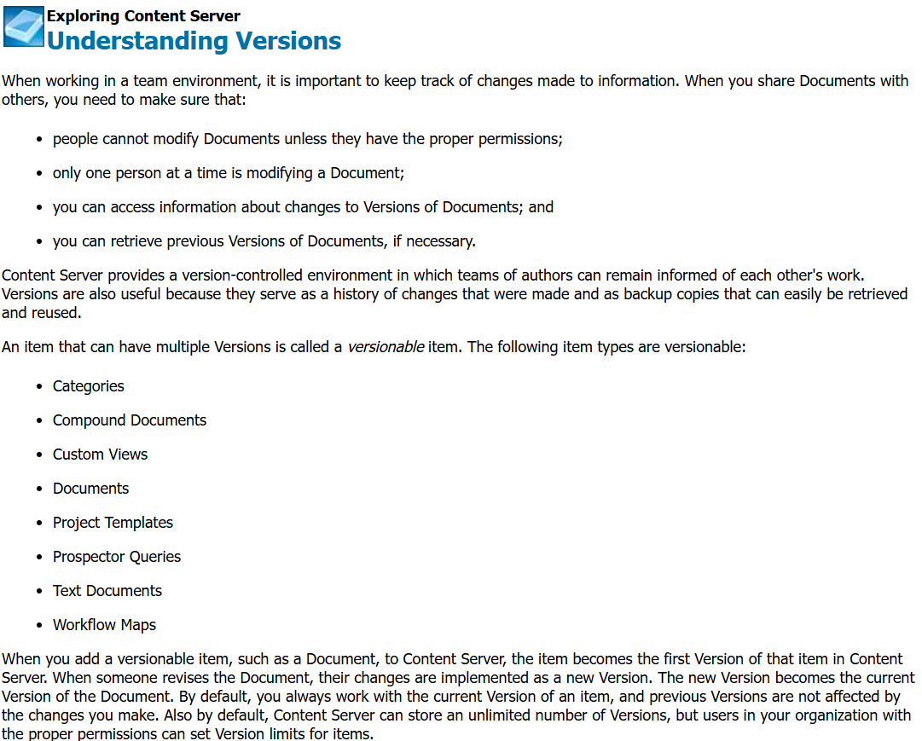
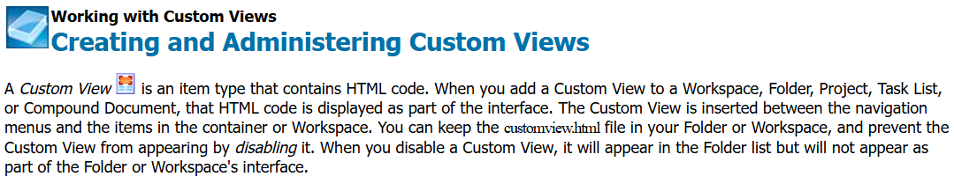

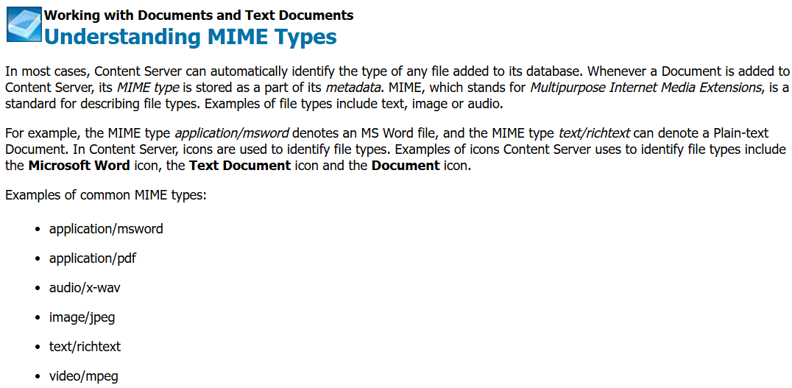
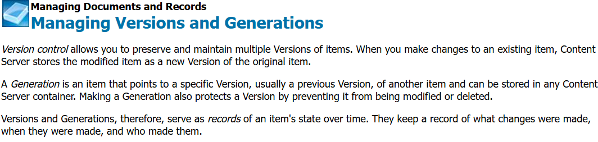

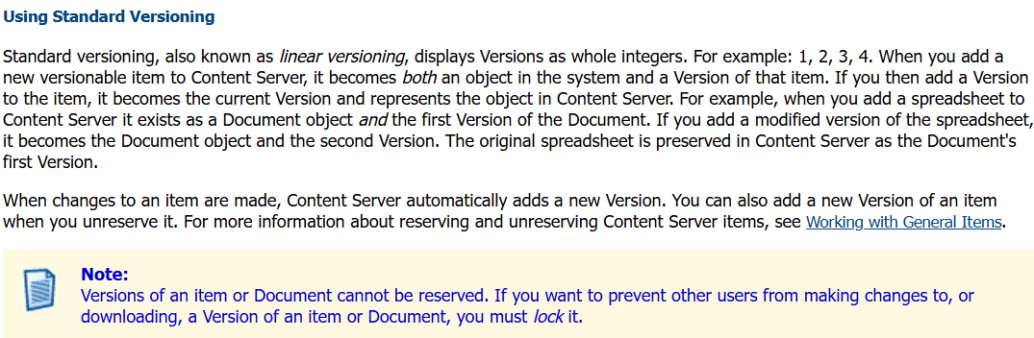
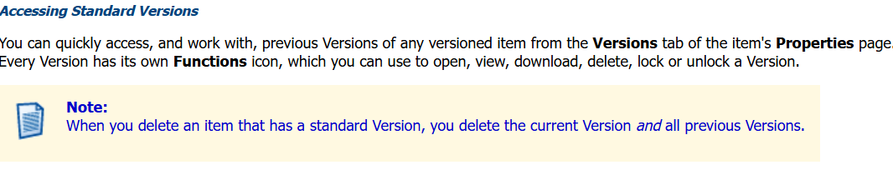
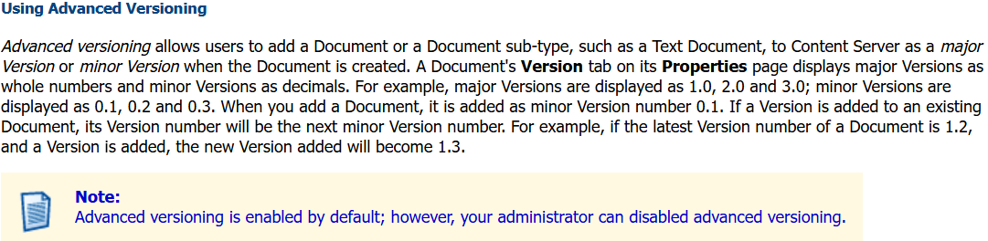

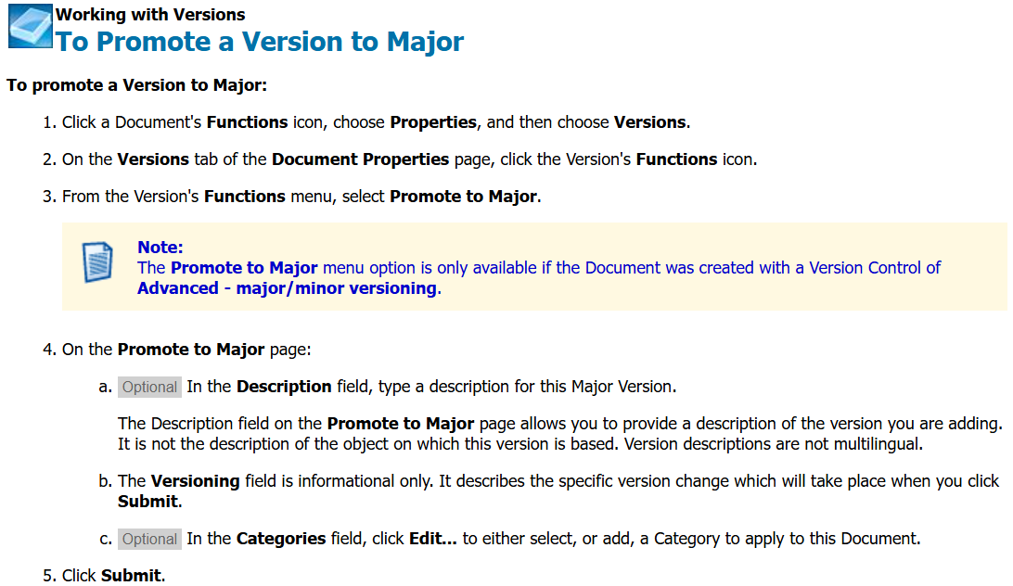

Collections: A Collection is a single location within which you store pointers to multiple items. Creating a Collection is a way to organize information stored in various locations. These pointers enable you to quickly, and easily, access the original items.
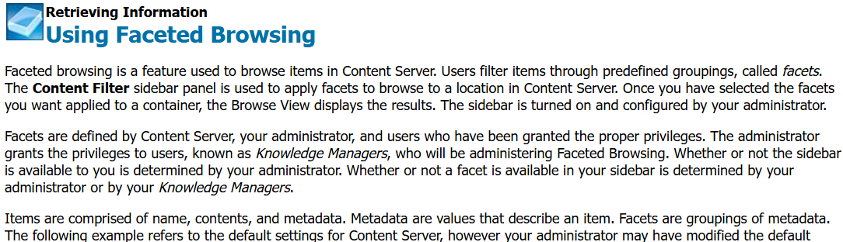

 | Using Virtual Folders  Working with Virtual Folders
Once a Virtual Folder has been created, users who have been granted See Contents permissions to that Virtual Folder can use it to browse the Virtual Folder's predefined facets.
You will see a browse banner above the sidebar when:
a user selects a facet from the available facets in the Content Filter panel of the sidebar, or
a user selects a Virtual Folder
The Browse Banner
The browse banner appears across the entire page, above the sidebar. It will display whenever you are accessing a faceted browse view of Content Server's contents. The options that the browse banner displays change dynamically, depending on your permissions.
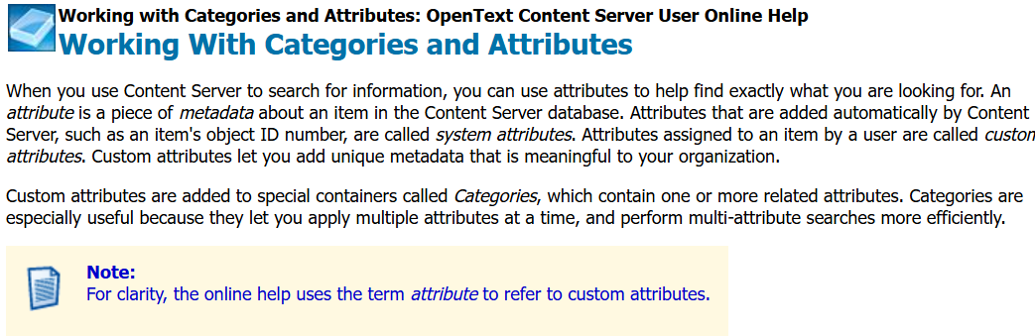

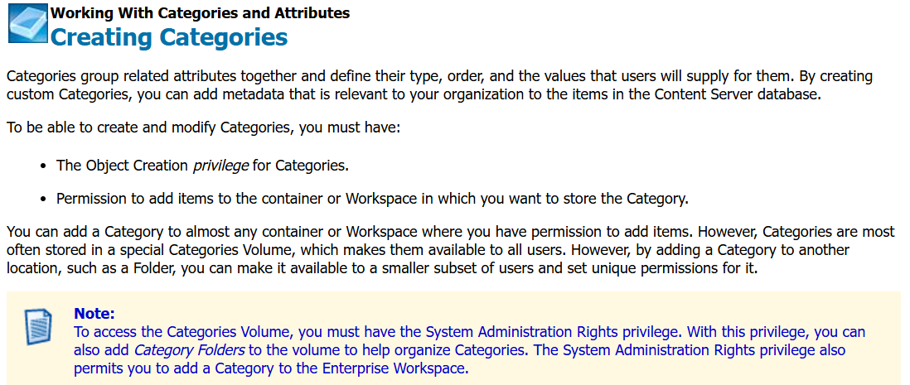

 | Working with LiveReports: OpenText Content Server User Online Help  Working with LiveReports
LiveReports provide access to information in your organization's Content Server database, and enable you to find, organize and present the information stored there. LiveReports obtain information by issuing Structured Query Language (SQL) statements to the database. Since SQL statements can alter or delete critical data, the permission to add or edit LiveReports is restricted to the administrator by default.
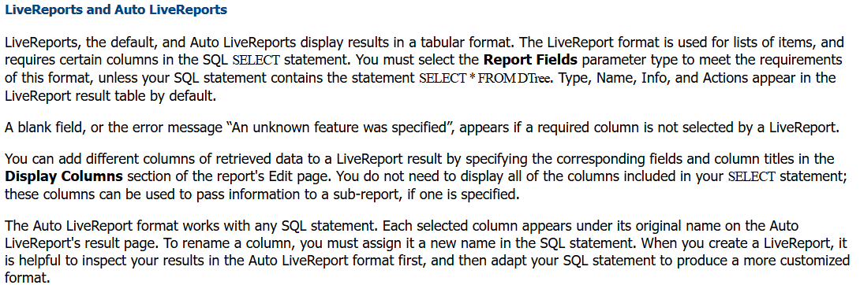

 | Using Workflows  Understanding Workflows
Workflows are business processes that are defined in Workflow Maps. A Workflow Map is a graphical representation of the business process. When you start, or initiate, a Workflow, Content Server creates a working copy (or instance) of the Workflow Map, which describes the business process and begins to execute it. The work that occurs during the execution of the business process is stored within a Workflow instance. Each time the same project or business process needs to be performed, you initiate another instance of the Workflow Map. For more information about Workflow Maps, see Introducing Workflows.
Workflows consist of a series of linked steps. Steps represent tasks, processes, or events in the Workflow, and the links that connect them define the processing path. Some Workflow steps may require participants to perform tasks, such as reviewing information, entering a comment, or attaching a document. These step tasks appear as Assignments to the users assigned to complete them. For example, if you are assigned a Workflow task, that task will appear on your My Assignments page and the Assignments tab of the My Workflows page whenever the Workflow execution reaches the step. Other Workflow steps execute automatically, with no input from Content Server users.
Participating in Workflows
If you are a Workflow participant, the Workflow step assigned to you appears on your My Assignments page when the Workflow arrives at that step. For more information about performing Workflow assignments, see Performing Workflow Assignments.
Managing Workflows
If you initiate a Workflow or are its manager, you monitor the progress of the Workflow or modify it on the My Workflows page. For more information about monitoring or managing Workflows, see Managing Workflows and Monitoring Workflows and Assignments.
Completing Workflows
When a Workflow is complete, the initiator and Workflow managers can archive or delete the Workflow instance, unless the Workflow Map contains an automatic completion action.
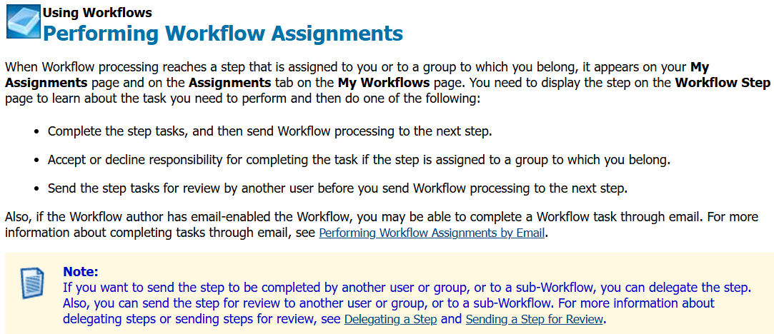

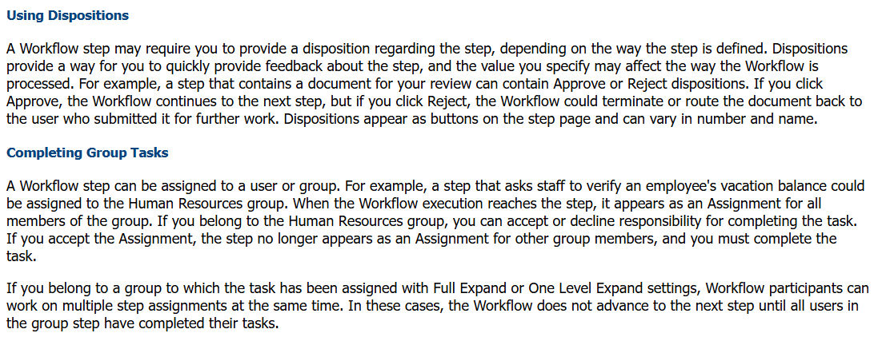

 | Using Workflows  Managing Workflows
A Workflow manager can monitor an executing Workflow to ensure that it proceeds properly. A Workflow manager with the appropriate permissions can perform the following operations:
- Stop, which permanently halts Workflow execution
- Suspend, which temporarily pauses Workflow execution
- Resume, which restarts a suspended Workflow
- Archive, which moves stopped or completed Workflows to the archived Workflow list
- Delete, which allows you to remove stopped or completed Workflows
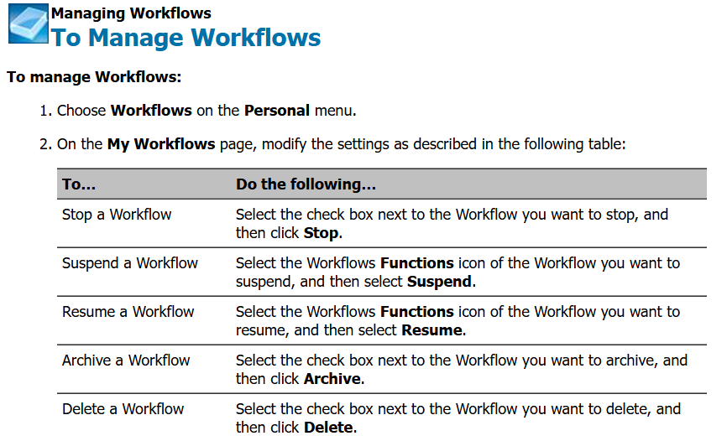

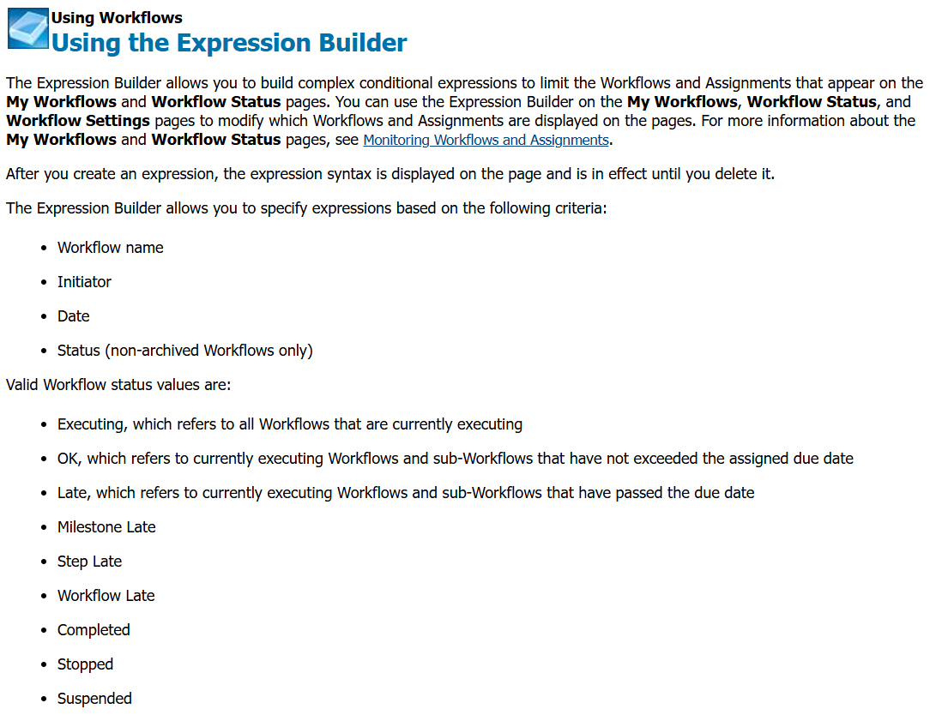

Summary Table:
Status | Is Executing? | Due Date Met? | Description
Executing | ✅ | Mixed | Workflow in progress
OK | ✅ | ✅ | Executing and on time
Late | ✅ | ❌ | Executing but overdue
Milestone Late | ✅ | ❌ | Milestones overdue
Step Late | ✅ | ❌ | Steps/tasks overdue
Workflow Late | ✅ | ❌ | Entire workflow due date missed
Completed | ❌ | N/A | Finished successfully
Stopped | ❌ | N/A | Manually terminated
Suspended | ❌ (paused) | N/A | Paused temporarily; can be resumed

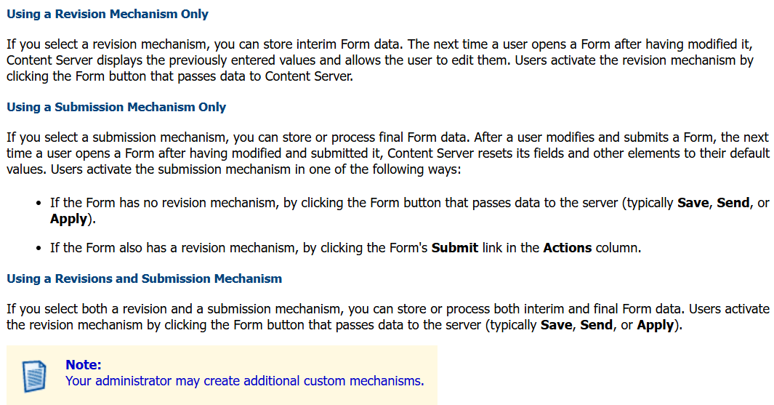

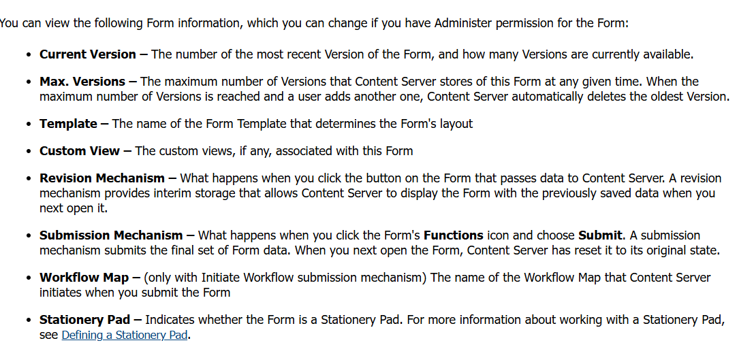

Here's your content reformatted into a clear table with each configuration parameter described in a single line per row:
Parameter | Description
Static File Location | Allows the user to browse and select a document in Content Server to be used as the data source.
File Type | Lets the user choose the file type as a data source: either Separated Values (CSV, tab-delimited, etc.) or HTML Table.
Content Type | Appears only for Separated Values; allows choosing how cells are quoted: No Cells Are Quoted (fastest), All Cells Are Quoted, or Some Cells Are Quoted (robust and best for Excel exports).
Assume Strict Syntax | Indicates if the data has a strict, predictable syntax; applies to All/Some Cells Are Quoted for CSV and to well-formed HTML tags like , , ; not recommended if syntax is unpredictable.
Column Separator | Appears only for Separated Values; sets the character separating data cells, e.g., comma for CSV, tab for tab-delimited; tab can be inserted using the \t link.
Row Separator | Appears only for Separated Values; sets the character separating rows, such as carriage return (\r), linefeed (\n), or both; links provided to insert these non-keyboard characters.
Quote Character | Appears only for Separated Values; defines the character (usually double quote) used to quote cells containing the separator character (e.g., a comma in CSV).
Escape Quote Characters | Appears only for Separated Values; sets how quote characters within quoted cells are escaped (e.g., "" for a double quote inside a quoted string); alternatives can be configured.
Let me know if you want this exported to Excel, CSV, or as a downloadable table format.

Data Source Types:

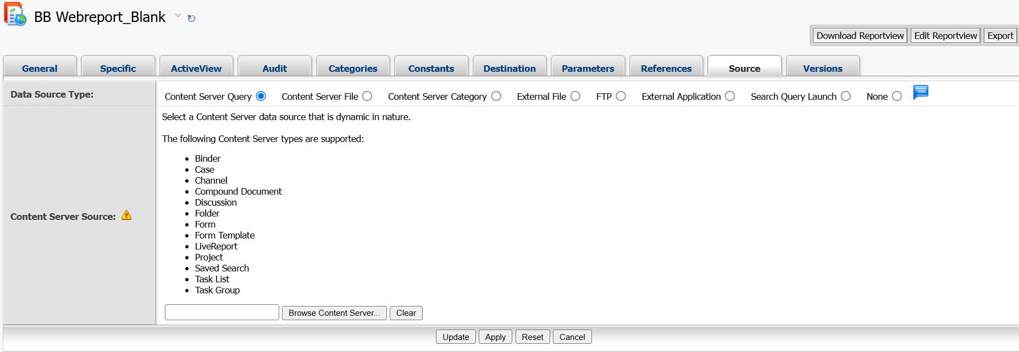
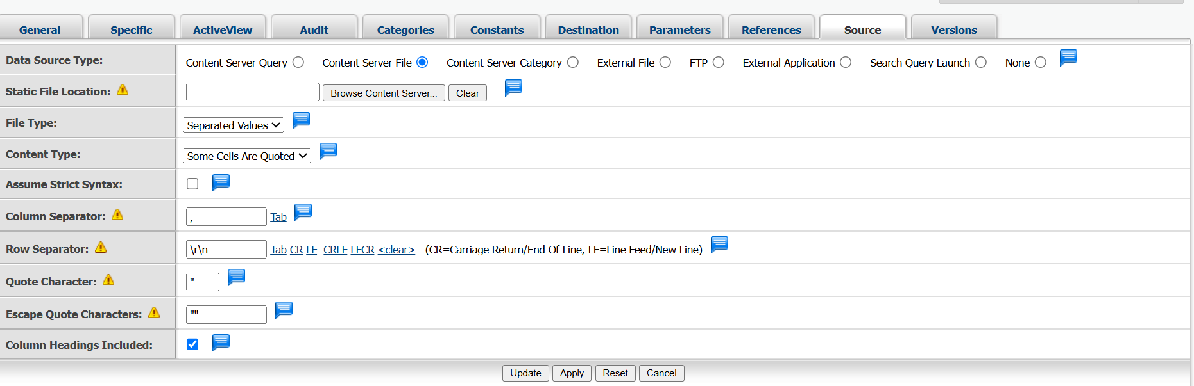

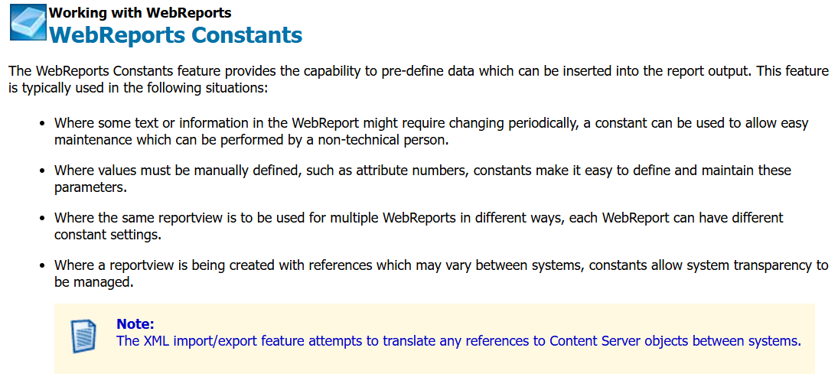
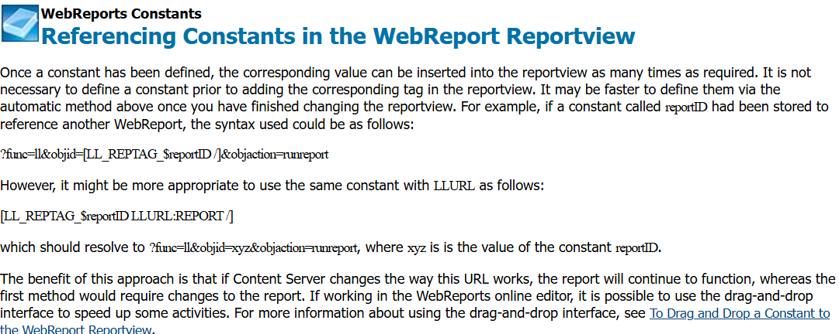

 | Working with WebReports  Using Parameters
When running a WebReport, parameters can be included in the URL for the WebReport itself as well as for the associated data source. These two parameter types, WebReport parameters and Data Source parameters, are described below.
Data Source Parameters
The data sources, LiveReports and Search Queries allow input parameters to be defined and collected when the report is run:
- When a LiveReport is being used as the data source, the standard LiveReport prompting will be allowed prior to the WebReport executing if no parameters have been supplied in the URL. In this scenario, when the WebReport is run, the user is presented with the LiveReport prompts much as if they had run the LiveReport directly. Once the user has entered the required prompts then the WebReport continues as normal.
- When a WebReport has been defined with a saved query as the data source, it is possible to insert variables into the full text search specification of the saved query. For example, the term %1 can be placed in the Full Text Search Terms field of any full text search boxes. These variables will be substituted with any corresponding parameters in the URL. URL parameters follow the same convention as a LiveReport.
For example, inputlabel<x>=value, where <x> is a number from 1 to 99 which corresponds with variables %1, %2 and so on.
Example
...?func=ll&objId=47478&objAction=RunReport&inputLabel1=WebReport&nexturl=...

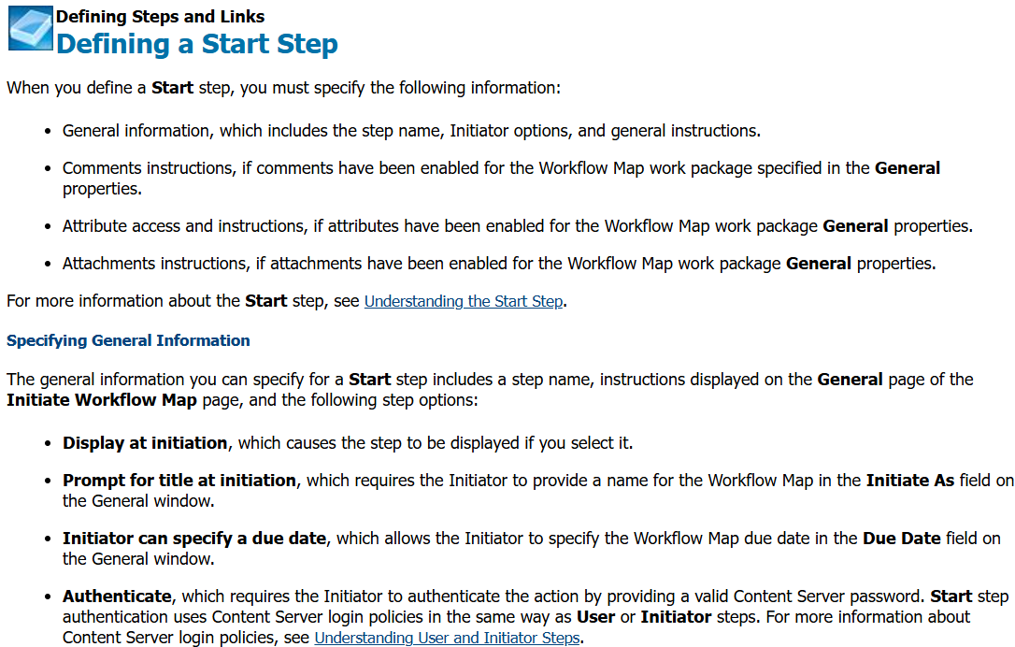

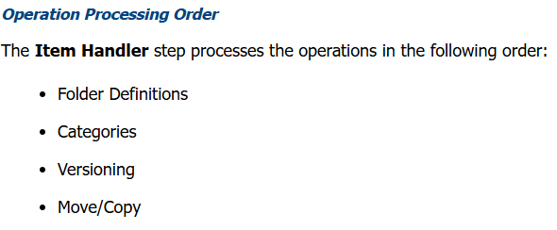
Step Type | Purpose / Use | Example Use Case
Start | Entry point of the workflow. Defines who starts it and with what permissions and attachments. | Initiating an invoice approval workflow.
User | Manual task step where a user/group must perform an action. | "Approve", "Reject", or "Review" a document.
Evaluate (Evaluate Step) | Makes decisions based on workflow attributes, categories, or form data. | Route to different departments based on "Invoice Amount".
Process (Process Step) | Executes automated back-end tasks such as setting values, promoting versions, or triggering other workflows. | Automatically update a category field or promote a version.
Item Handler | Used to apply actions (e.g., category updates, document check-in/out) to workflow attachments. | Add/remove category metadata from an attached document.
Form Task | Presents an e-Form (Smart View or Classic) for user input, which can guide workflow direction. | Gather comments or update invoice details via a form.
WebReport | Executes a WebReport mid-workflow to perform advanced logic, show data, or perform updates. | Run a WebReport to fetch user data, update metadata, or email reports.
Delay | Pauses the workflow for a set duration (hours/days). | Wait 24 hours before sending escalation.
End | Marks the completion of a workflow. | Used when no more steps remain.
Sub-Workflow (or SubProcess) | Invokes a separate workflow from the current one. Can pass parameters and resume on completion. | Send a document for legal review in a separate workflow.
Synchronization | Waits until multiple parallel paths merge before continuing. | Ensure two departments approve before moving to the next step.
Dispatcher (User Dispatcher) | Assigns tasks dynamically to one member of a group (round robin, random, or load-based). | Assign tickets to an available support agent.
Form Evaluation | Evaluates form data (like Evaluate Step but specific to Forms). | Route form to correct department based on field values.
Script Step (Advanced) | Executes custom OScript or JavaScript logic (less common, requires dev setup). | Integration with external APIs or systems.

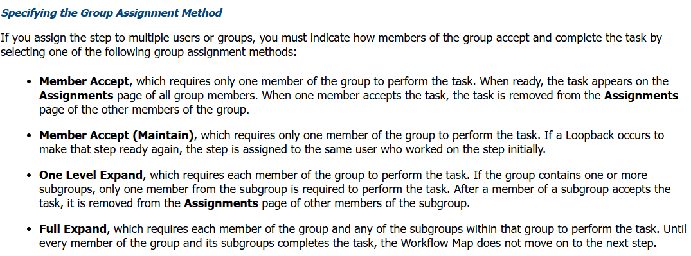
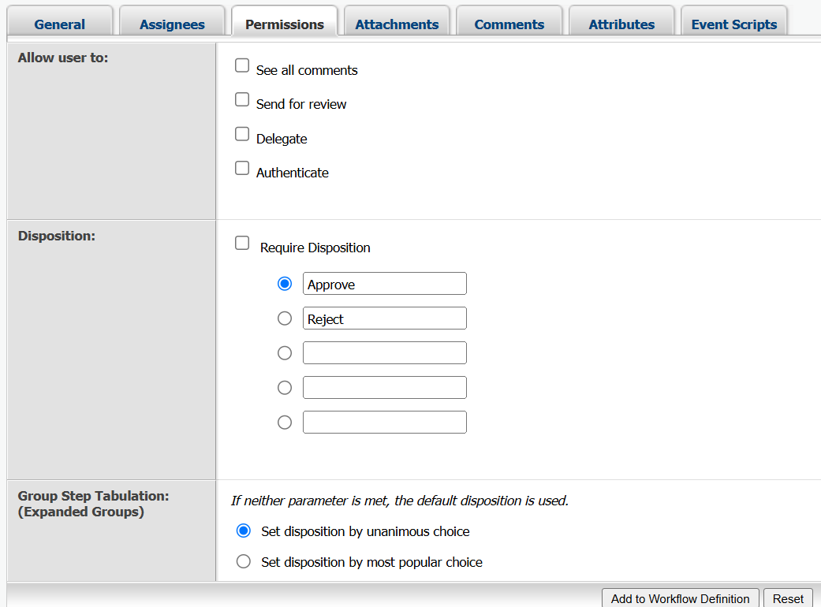
 | Defining Steps and Links  Defining an Evaluate Step
When you define an Evaluate step, you must by specifying the following information:
- A step name.
- Whether Content Server must recalculate the Workflow Map due dates after the step is processed.
- The conditional statements you create in the Expression Builder that the step uses to determine how to route the Workflow.

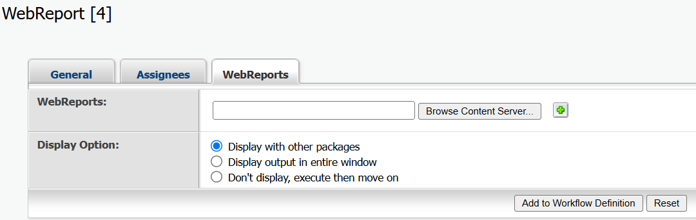
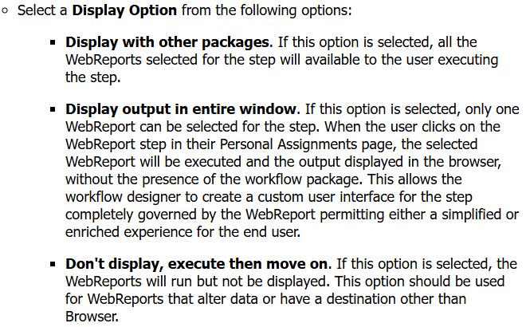

✅ Frontend in Content Server
Definition:
The frontend is what users see and interact with — like the Content Server web interface where they open folders, upload documents, start workflows, or run reports.
Example Use Case:
A user logs in to Content Server, opens a workspace, uploads a document, and starts a workflow. All these actions are done through the frontend (web browser screen).

✅ Backend in Content Server
Definition:
The backend is the server-side part of Content Server. It handles data storage, processing, and logic, such as:
- Storing documents in the database or file system
- Running SQL queries via LiveReports
- Executing workflows and scripts
- Managing user permissions and versioning
Example Use Case:
When a user uploads a document from the frontend, the backend stores it in the server, records metadata in the database (like DTree table), and applies permissions or triggers workflows.

🔁 Summary Table
Part | What It Does | Example Action
Frontend | User interface (web browser view) | Clicking on folders, uploading files
Backend | Server logic and database handling | Saving data, executing reports, workflows

📌 OVERVIEW (Think of the Process Like a Factory)
Imagine a factory where documents are:
- Picked up
- Processed (content is read/extracted)
- Indexed (catalogued for search)
- Made searchable

🔁 STEP-BY-STEP FLOW (Modified for Simplicity)

🔹 1. Enterprise Data Source Folder
- What it is: This is your starting point—a folder where your documents are stored in Content Server.
- Example: You save a PDF or Word file to a folder.

🔹 2. Data Flow Manager
- What it is: The controller or manager that tells the system:
➤ "Hey! A new file has arrived. Start processing it!"
- Job: It triggers the next steps to extract and index content.

🔹 3. Enterprise Extractor Process
- What it is: The reader of the document.
- Job: It reads the document contents like title, body text, author, etc.
- Example: If you uploaded a PDF, it reads the lines like:
"Invoice Number: 1234", "Total: ₹5000"

🔹 4. Enterprise Document Conversion
- What it is: The translator.
- Job: If the file is an image or a scanned PDF, it converts it to searchable text using OCR (Optical Character Recognition).
- Example: Converts a scanned handwritten note into searchable words.

🔹 5. Enterprise Prospector Importer
- What it is: The importer.
- Job: It saves the extracted and converted content into the system so it can be indexed.
- Think of it like: “Store this text in the index database.”

🔹 6. Enterprise Update Distributor
- What it is: The distributor or delivery system.
- Job: It ensures that updates (new documents, modified files) are sent to the right index engine for processing.
- It handles the flow of updated data to indexing.

🔹 7. Enterprise Index Engine for Partition 1
- What it is: The main indexer (brain).
- Job: It indexes the document's contents—i.e., it adds the document info to a searchable catalog.
- Example: Think of Google indexing web pages. This is like that—but for your internal documents.

🔹 8. Partition 1
- What it is: A storage section for indexes.
- Large systems use partitions to divide indexes and improve speed.

🔹 9. Enterprise Search Engine for Partition 1
- What it is: The search executor.
- Job: When a user types a search keyword (like "invoice"), this engine looks in the indexed partition to find matching documents.
- Example: You search “Invoice 1234” — this engine finds and returns matching results.

🔹 10. Enterprise Search Federators
- What it is: The coordinator when you have multiple partitions or search engines.
- Job: It combines search results from all partitions or locations.
- Example: If you have documents split across departments (HR, Finance), this brings results from all in one go.

🔹 11. Search Manager
- What it is: The top-level manager for search activities.
- Job: It coordinates all search-related tasks, handles user queries, manages configuration, and ensures everything works smoothly.

✅ Final Simple Diagram

📁 Data Source Folder
↓
🧠 Data Flow Manager
↓
📖 Extractor Process
↓
📝 Document Conversion (if needed)
↓
📦 Prospector Importer
↓
🚚 Update Distributor
↓
📚 Index Engine → 🗃 Partition
↓
🔍 Search Engine
↓
🌐 Search Federator (if multiple partitions)
↓
🧑 User gets search results!

💡 Real-Life Analogy
Imagine you're organizing your house:
- You collect papers (data folder),
- Read and sort them (extractor),
- Type scanned ones (conversion),
- Store info into your notebook (indexing),
- And later when someone says “Find electricity bill,”
  - You search your notebook (search engine),
  - Even if bills are split into different drawers (partitions),
  - You still get the right result instantly!

Term | One-Line Definition | Simple Explanation
OpenText | Software vendor for ECM solutions. | OpenText is a leading provider of Enterprise Content Management (ECM) solutions used for organizing, managing, and sharing content in businesses.
Content Server (CS) | Platform to manage and store content. | Content Server is a centralized system that helps businesses manage all their documents, metadata, and related content in a secure, organized way.
Enterprise Content Management (ECM) | System for managing enterprise content. | ECM is a set of tools and technologies used to capture, store, manage, and deliver content like documents and records for businesses.
Metadata | Data describing other data. | Metadata provides details like document name, creation date, and author, helping identify and manage content.
Versioning | Storing multiple versions of a document. | Versioning allows the system to track changes made to a document over time, storing each revision separately.
Cluster Architecture | Grouping servers for performance. | A cluster consists of multiple servers that work together to handle large volumes of requests and provide high availability.
Load Balancer | Distributes traffic to multiple servers. | A load balancer directs user requests to different servers based on their availability or current load to ensure optimal performance.
LURL | Load Balanced URL for accessing servers. | LURL (Load Balanced URL) is a generic URL that directs users to an available server in a clustered system for load distribution.
Frontend Server | Server handling user requests. | Frontend servers are responsible for interacting with end users, handling UI requests like document retrieval or uploading.
Backend Server | Server for background tasks. | Backend servers handle background processes, such as indexing, search management, and other system administration tasks.
Go-Live | Final deployment of an application. | Go-Live refers to when a project moves from development to being available for real-world use by end users.
Environment | The setup where a system is deployed. | Environments like Dev, QA, and Prod refer to different stages of the system's lifecycle (development, testing, and production).
Requirement Gathering | Collecting system needs. | This is the process of gathering detailed business requirements from stakeholders to define system functionality.
Development | Building the application. | Development involves creating the application by configuring tools, setting up databases, and writing code (in languages like HTML, SQL).
Testing (QA) | Verifying the system works correctly. | Quality Assurance (QA) involves checking the system against requirements to identify and fix any bugs or issues.
UAT (User Acceptance Testing) | Final user testing before launch. | UAT is the process where end users test the system to ensure it meets their needs and expectations.
Deployment | Installing the system on live servers. | Deployment is the process of installing the application to the production environment, making it available to users.
DTree | Table for all objects (documents, folders). | DTree stores the metadata for all objects in the system, such as documents and folders, linking them to their properties and structure.
KUAF | Table for users and groups. | KUAF contains information about users and groups in the system, such as their IDs, roles, and email addresses.
DVERSDATA | Stores document version information. | This table keeps details about each version of a document, including the version number, size, and creation date.
LLATTRDATA | Table for category attributes. | LLATTRDATA stores attribute values for categories assigned to documents or folders, such as metadata for classification.
DTREEACL | Table for permissions and access control. | This table defines who can access or perform actions (read, write) on specific objects (documents, folders) in the system.
DAUDITNEW | Stores audit logs of system actions. | DAUDITNEW logs user actions and events, tracking changes made to documents or system settings for audit purposes.
Subtype | Identifies object type (e.g., folder, document). | Subtype helps identify the type of object, such as whether it’s a folder (0) or a document (144).
DataID | Unique identifier for an object. | Each object in Content Server, like a document or folder, has a unique DataID that distinguishes it from other objects.
ParentID | Refers to the parent object. | ParentID identifies the higher-level object (such as a folder) that an object belongs to.
OwnerID | User ID of the object's owner. | OwnerID represents the user who created or owns the object (document/folder).
RightID | Identifies user/group with access rights. | RightID associates a user or group with specific access permissions to an object.
Permissions | Defines allowed actions (view, edit, delete). | Permissions determine who can access an object and what actions (read, write, delete) they can perform on it.
LiveReport | SQL-based report for querying CS data. | LiveReport uses SQL queries to directly pull data from Content Server’s database for custom reporting.
WebReport | Tag-based report for user-friendly outputs. | WebReports use special tags to generate user-friendly reports, making them more readable and interactive.
[LL_REPTAG] | Special tag for WebReports. | [LL_REPTAG] is used within WebReports to apply specific actions, like updating a value or retrieving object details.
NODEINFO | Tag to show object details. | NODEINFO retrieves information like object name, ID, and other metadata about a document or folder.
NODEACTION | Tag to modify object data. | NODEACTION is used in WebReports to update an object’s metadata or properties.
Workflow | Automated task sequence in Content Server. | Workflows automate business processes by guiding documents or tasks through various stages (approval, review, etc.).
User Step | Task assigned to a user in a workflow. | User Steps involve tasks that require manual input or approval from specific users.
Evaluate Step | Logic check in a workflow. | Evaluate Steps check conditions or apply logic, like deciding if a task should proceed based on criteria.
Item Handler | Automatically updates document attributes. | Item Handlers in workflows are used to auto-update metadata or document properties during workflow steps.
Form Template | Pre-defined form for data collection. | Form Templates are used in workflows to capture user input or data for documents being processed.
OScript | Scripting language for Content Server. | OScript is a scripting language used for creating custom workflows, reports, and integrations within Content Server.
Source Type | File format for data import. | Source Type refers to the format of incoming data, like CSV, that is used in workflows or reports.
Retention Period | Time a document must be stored. | The Retention Period defines how long a document should be kept before being deleted, based on business rules or legal requirements.
Smart View | Modern user interface for Content Server. | Smart View offers an enhanced user interface that simplifies document access and management in Content Server.
Perspective | Customizable user dashboard layout. | A Perspective is a personalized layout of widgets and views that help users quickly navigate Content Server.
Widget | UI component for displaying information. | Widgets are small, customizable modules on the Content Server interface that display information like task lists or favorite documents.
Landing Page | Home page for users in Content Server. | The Landing Page is the first screen users see, offering quick access to common tasks and important features.

✅ 1. Core Architecture of OpenText Content Server (Theory Answer)
The core architecture of OpenText Content Server is a multi-tier system that connects users, application logic, and data storage to manage content efficiently across the organization. When a user accesses the system through a web browser like Chrome or Edge, their request is sent to a Web Application Server such as Microsoft IIS or Apache Tomcat. This web server hosts the Content Server application, which processes the request and interacts with the backend database to fetch or store the required content. The application uses Microsoft SQL Server or Oracle as its database engine to store all metadata, user details, permissions, and document relationships. The architecture also includes frontend servers that handle user requests such as uploading, downloading, and viewing documents, and backend servers that perform background operations like indexing, searching, and workflow execution. For larger implementations, Content Server supports cluster architecture where multiple servers are grouped to share the load, and a load balancer is placed in front of them to distribute incoming requests evenly across the servers. Each user connects using a common LURL or load-balanced URL, and their session is routed to an available server in the cluster. This ensures high availability, fault tolerance, and improved performance. All servers in the cluster point to a single centralized database, ensuring consistency in content management across the organization.

✅ 2. Software Development Life Cycle (SDLC) in Content Server Projects (Theory Answer)
The Software Development Life Cycle, or SDLC, in Content Server projects typically follows a structured approach starting with requirement gathering, where business analysts work with stakeholders to collect detailed inputs about the features, user interface, and workflow expectations of the system. Once the requirements are finalized, the development phase begins, which in the case of OpenText Content Server is mostly configuration-based with around 80% of the work involving setting permissions, categories, workflows, and reports, and the remaining 20% involving coding with technologies like HTML, SQL, and sometimes OScript. After development, the application is handed over to the QA or testing team who write and execute test cases to verify that the system functions as expected and meets business needs. Any bugs found are sent back to the development team for fixes. Once all test cases pass, the application moves into User Acceptance Testing or UAT, where actual business users validate the application from a real-world usage perspective. After successful UAT, the application is deployed to the production environment, which is the live system used by end users across the organization. Post go-live, any feedback or enhancement requests from users are logged and processed through future development cycles, ensuring continuous improvement of the system. This structured SDLC ensures the project is delivered with accuracy, quality, and alignment to business goals.

✅ 1. Core Architecture of OpenText Content Server (Short & Easy)
OpenText Content Server has a multi-layer architecture. Users access it through a web browser, and the request goes to a web application server like IIS, which connects to the Content Server application. The application then interacts with the database—usually SQL Server or Oracle—to fetch or store content. It uses frontend servers to handle user actions and backend servers to manage background tasks like indexing and searching. In large setups, it uses clustered servers with a load balancer, so user traffic is shared across multiple servers using a common LURL. All servers point to one central database, which keeps everything synced and consistent.

✅ 2. Software Development Life Cycle (SDLC) in Content Server Projects (Short & Easy)
In Content Server projects, SDLC starts with requirement gathering from business users. Then the development team does mostly configurations and some coding using SQL or HTML. After that, the QA team tests the system. Any bugs found are fixed and re-tested. Then comes UAT, where business users check if the system meets their needs. If all is good, it's deployed to the production environment. After go-live, users give feedback, and enhancements are planned in the next cycle. So it's a step-by-step process from planning to final delivery and support.

